# Inclusivity

——Include you and include all

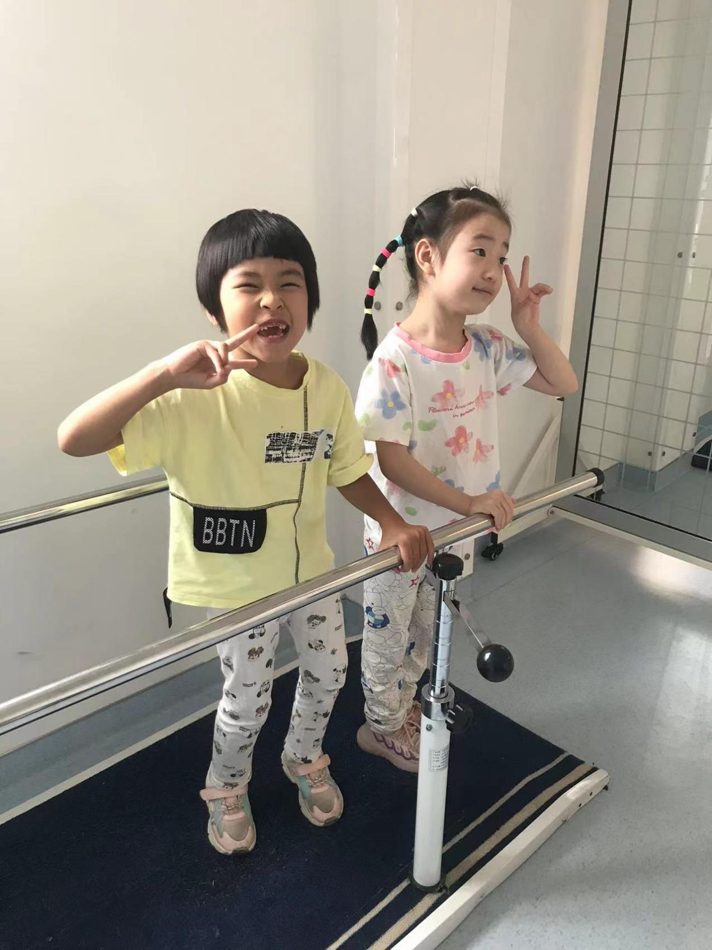

# Overview

We have grown up, and most of us probably think that the world is more or less unfair, even if the unfairness permeates every corner. But we can do what we can to remove the barriers that give everyone an equal chance at self-fulfilment in every way we can.

# Removal of absolute scientific bias

## Survey on Genetically Modified Food and Genetically Modified Technology

The emergence of genetically modified (GM) technology is a technological change that affects every aspect of human life. However, based on our personal experience, most people in China are unaware of GM technology and have a complete rejection of it, despite the fact that many GM products are already in use. We believe that the public's rejection of GM technology is most likely based on news reports and lack of knowledge. In addition, we think it is clear that a lack of adequate understanding of science and a complete rejection of it will hinder scientific progress. For this reason, we need to make efforts to improve the general public's knowledge and eliminate absolute scientific bias.

Firstly, we have done some research on the public's understanding and acceptance of GM food. It can be seen that the majority of people are uncertain about the safety of GM food, and only a small number of people think it is completely safe.

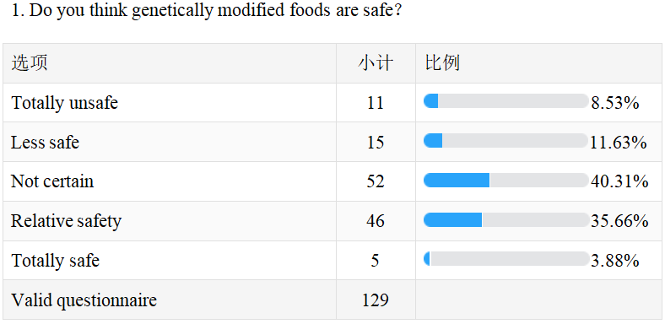

Among the choices for the disadvantages of genetically modified foods, 75.97 per cent believe that they may affect human health, indicating that the majority of people are genuinely concerned about the effects of genetically modified foods on the human body.

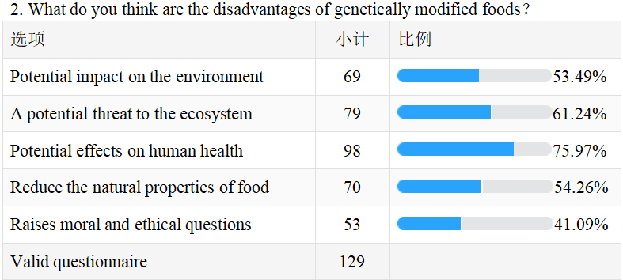

However, when people were asked about their knowledge of GM technology, less than three in ten believed that they had a certain degree of understanding of GM technology, and the majority (65.12 per cent) believed that they had only a basic understanding of GM technology. As the popularisation of GM technology is still lagging behind in China, there may still be a lot of pseudo-science in what they know.

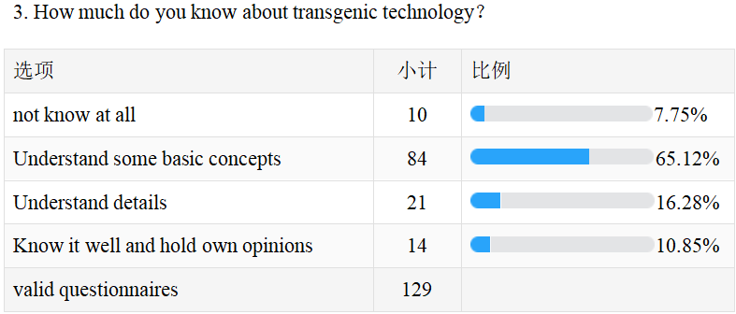

Most people believe that the popularisation of GM technology should be strengthened, which, in the opinion of our researcher, also confirms the relative lack of knowledge and desire of the public to understand GM. This lack of knowledge can lead to biased perceptions of an issue that people are not aware of. Having said that, our opinion that there is an absolute scientific bias against GM foods in China is still only based on what we have heard from people around us and our preliminary research. But this is enough for us to explore further and carry out our activities accordingly.**（上传word，转基因问卷中文版）**

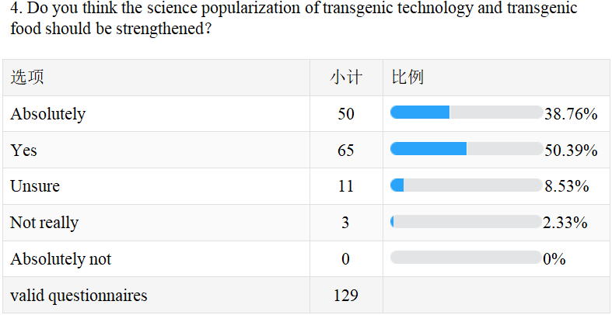2.Our Reflections and Efforts

Through our reflection on the current situation and our ability to consider it. We believe that the best way to eliminate prejudice against GM technology is to popularise it. We created a set of questions on GM technology to be used in our offline quiz, and we distributed gifts to those who answered 80% or more of the questions correctly.

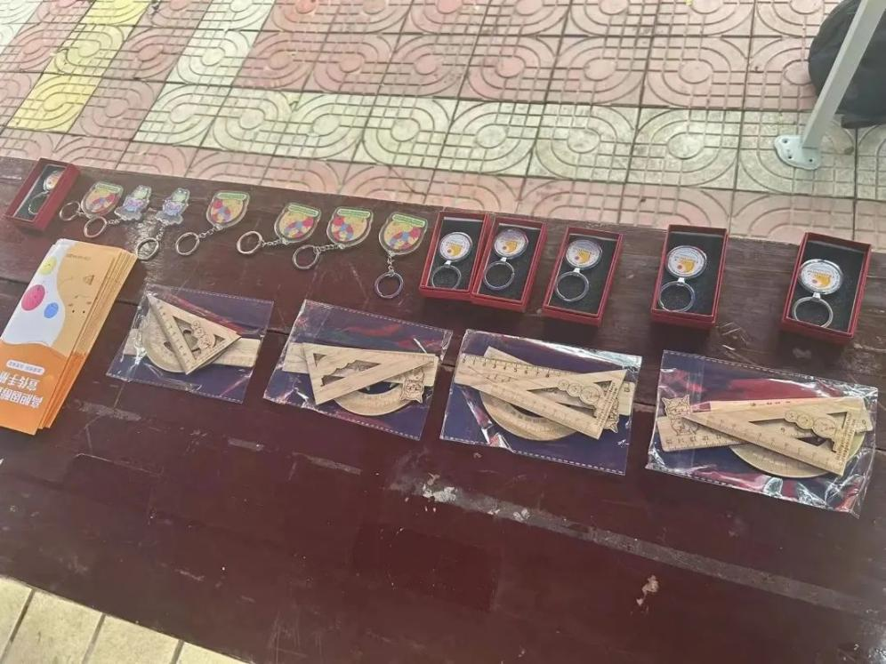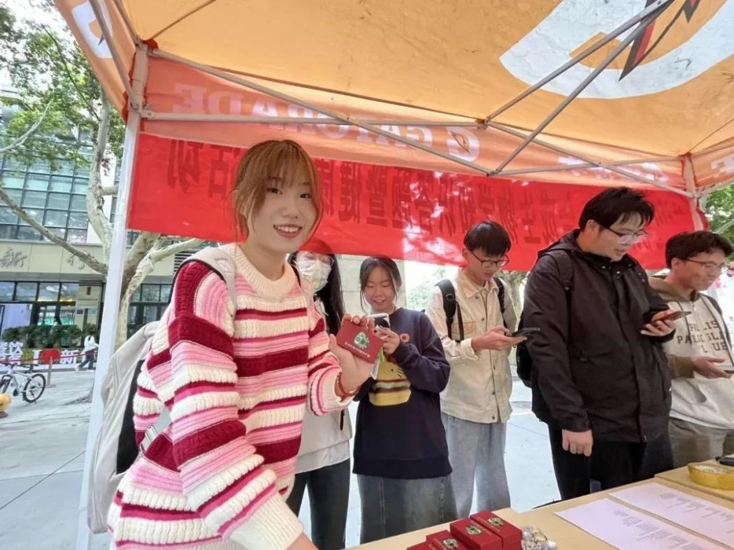

And, we have produced a series of science PPTs and recorded videos, two series in total, with a lot of design genetic engineering. (**传科普PPT）**Through these attempts, we have made efforts to promote the knowledge of the general public and hope to be able to bring help in eliminating the incomplete knowledge of the general public.

# Educational equity

## 01 Survey

We designed a questionnaire on educational equity and researched educational equity in society as a whole, educational equity in remote areas, and educational equity for women.**（问卷如文件，上教育公平问卷word）**

For the results of the questionnaire analyses, data were collected separately in terms of whether or not they were female and whether or not they were ethnic minorities. Regardless of any group, the number of people who think that education is unfair in the current society is greater than the number of people who think that education is fair in the society. And, there is a huge discrepancy between men's and women's perceptions of fairness in education for women. The questionnaire data are as in these documents.

## **02 Our Effort**

### 2.1 For Educational Equality in Remote Areas

Our region is Gansu Province in China, which is in the north-west of the country and is economically underdeveloped. In addition, many of our team members come from remote or economically underdeveloped provinces, or from rural and mountainous areas. The imbalance in education due to the remoteness of the regions can seriously undermine the rights of people to approach science and realise their own interests. We can't change the differences in economic conditions, but we can promote the right to education in remote areas through our actions and our voices. To this end, we created our presentation materials, collaborated with several clubs within our schools, and worked with schools such as the Beijing Institute of Technology and the University of Macau. In the end, a total of 12 teams were dispatched across China with our synthetic biology awareness PPTs and presentations on hypercholesterolaemia and chronic diseases.

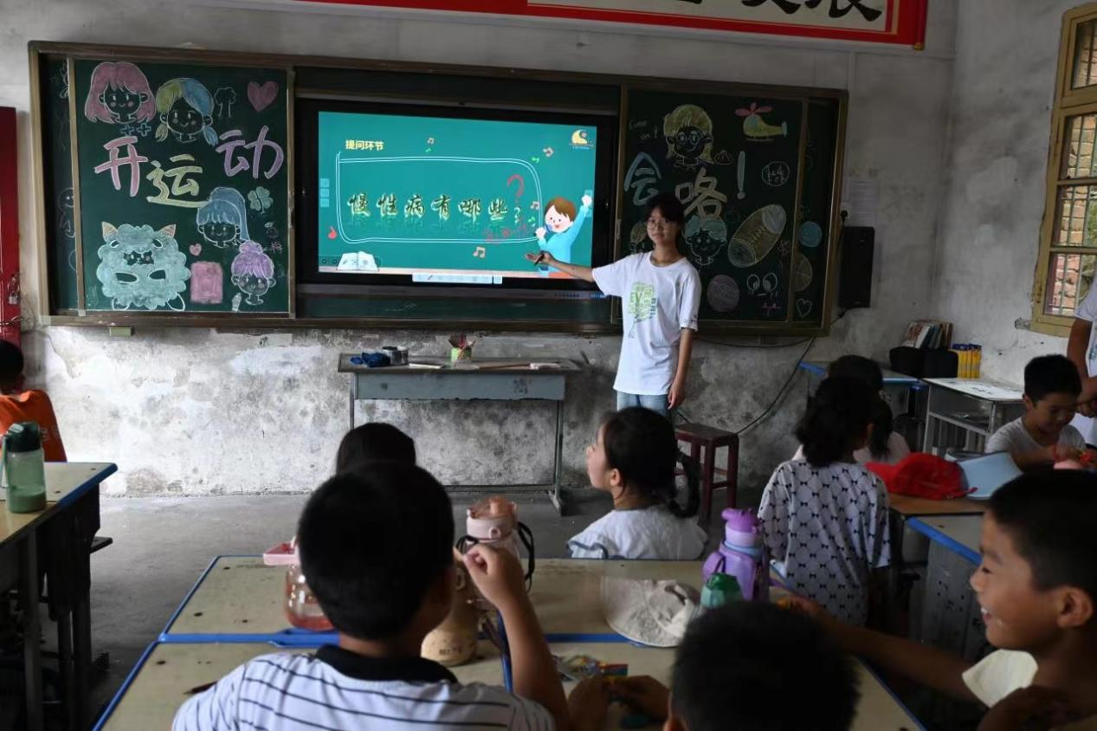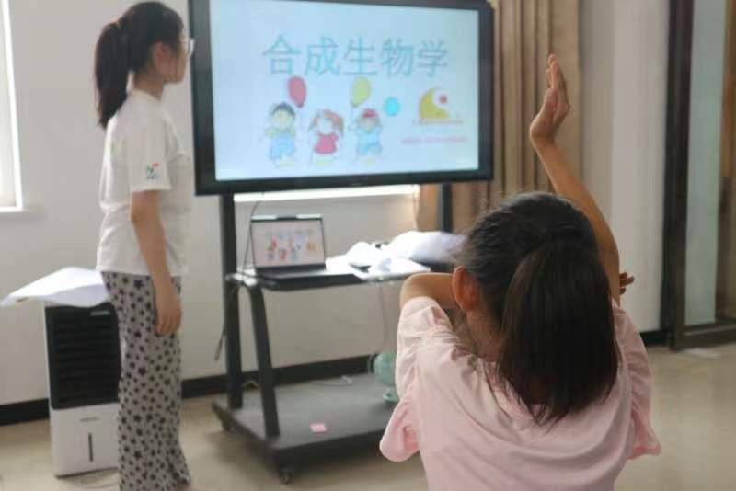

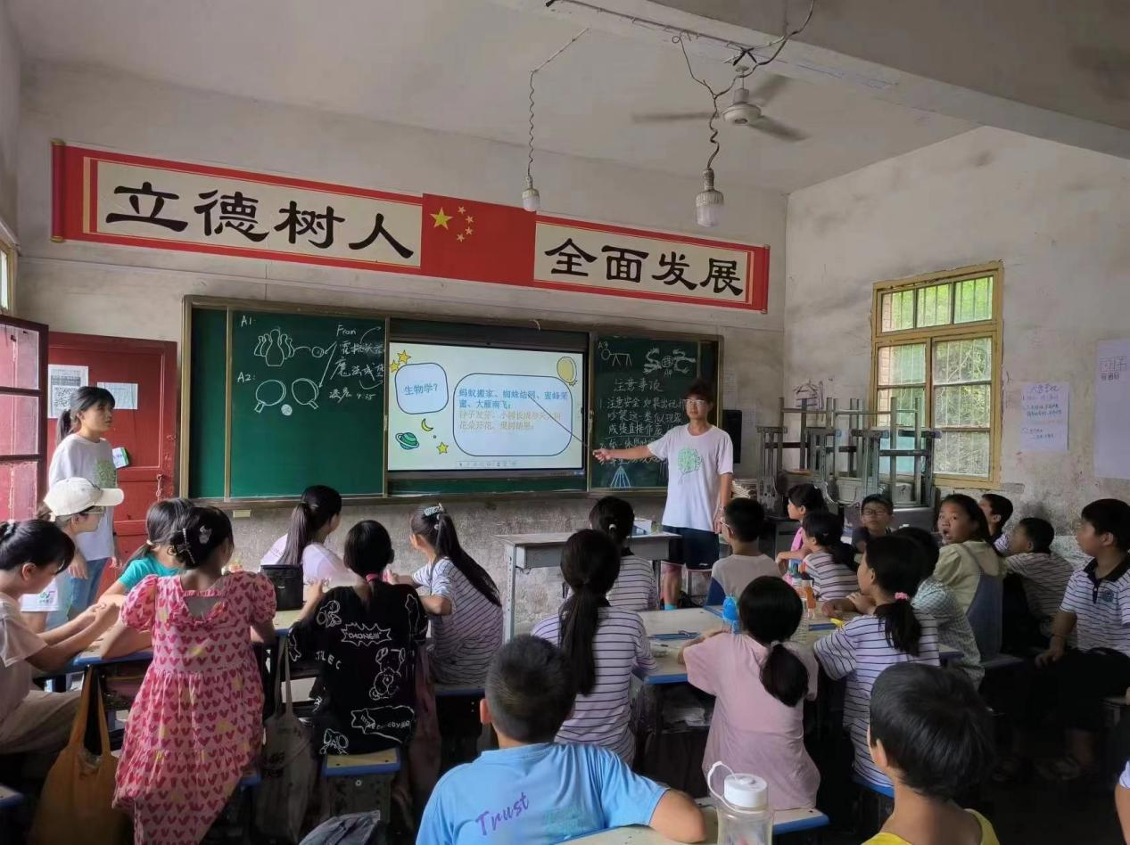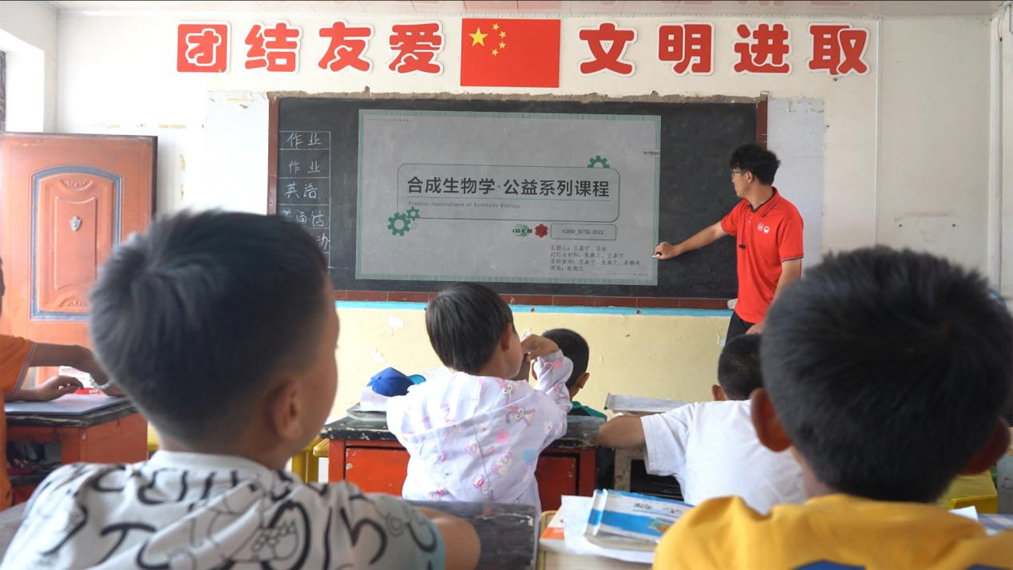

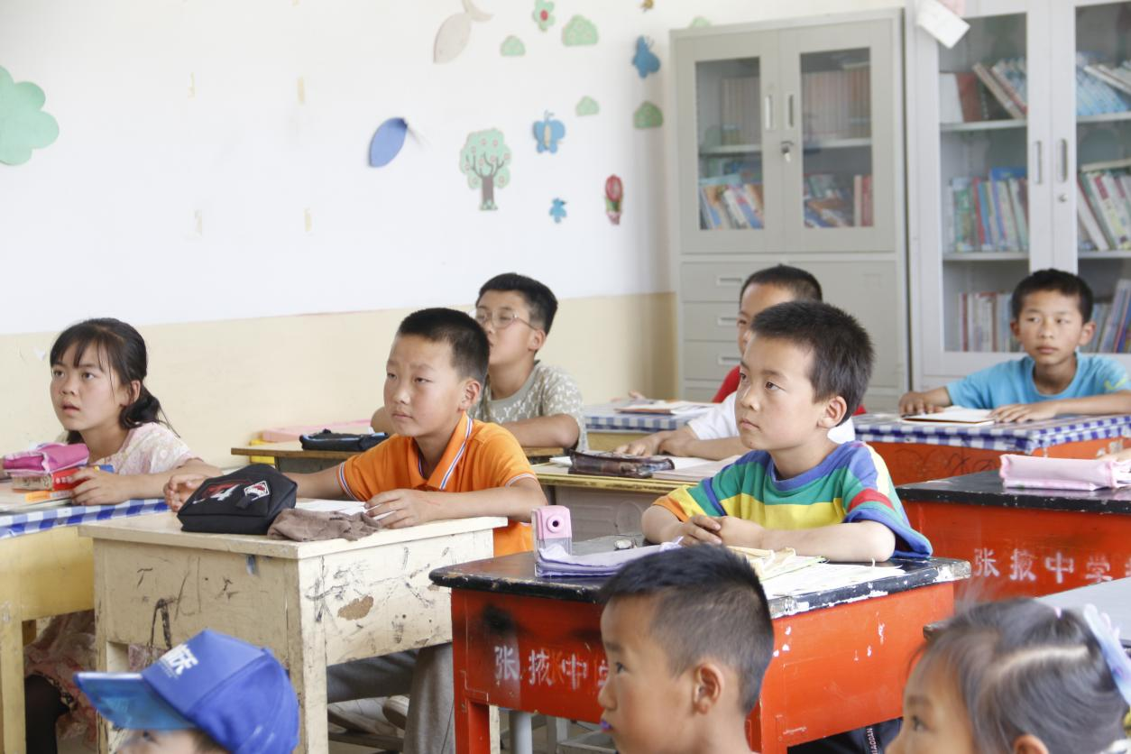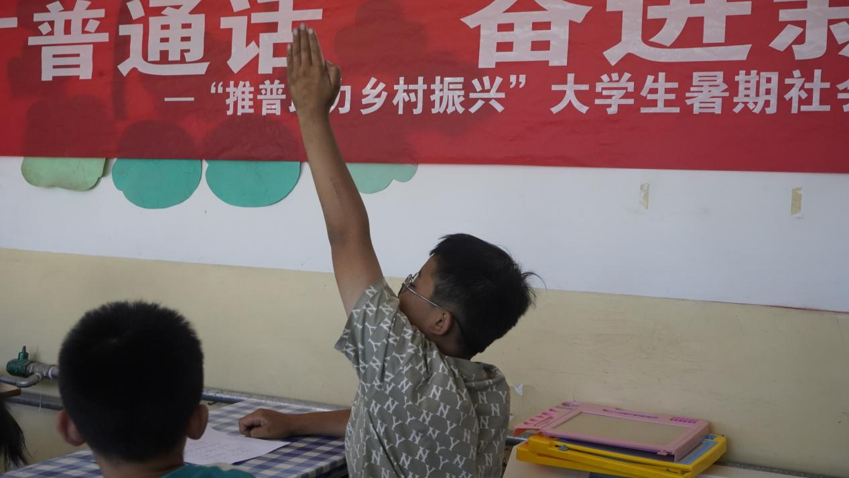

In addition, we launched our series of science courses and donated surplus stationery to the National Middle School in Taijiang County, Qiandongnan Miao and Dong Autonomous Prefecture, Guizhou Province. We not only try to promote education in remote areas through joint clubs to teach. We have also carried out local activities for students at all levels of primary, middle and high school.

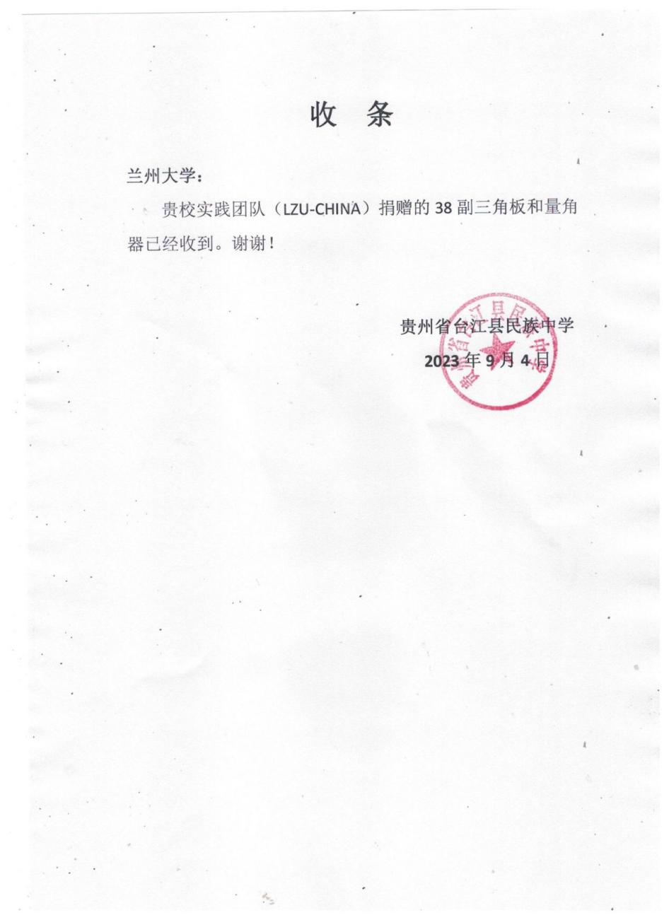

### **2.2 For Equality in education for ethnic minorities**

As urbanisation continues to accelerate, the number of migrant children is increasing throughout the country, and Gansu Province in the north-west of the country has a large number of migrant children. In addition, Gansu has been a multi-ethnic province since ancient times, with a population of more than 1,000 people from 16 ethnic groups, including Hui, Tibetan, Dongxiang, Tu, Yugu, Baoan, Mongol, Salar, Kazakh, and Manchu, with the Dongxiang, Yugu, and Baoan being the three unique ethnic minorities in Gansu Province. In Lanzhou, the capital of Gansu Province, the number of migrant children of ethnic minorities and the ensuing social problems should not be underestimated.

Firstly, there is the social plight of migrant children. Many of the migrant children live with their parents in urban villages or urban-rural areas, and while some of them are able to attend public schools, some have to attend private schools. The children's living environment, the quality of the education they receive, the degree of integration into the community, and family parent-child relationships are all very different from those of household children.

Secondly, there is the problem of education for ethnic minorities in the west, which is characterised by economic problems, the quality of education, and difficulties in implementing bilingual teaching. The development of the western ethnic minorities is relatively lagging behind, and the western ethnic minorities still suffer from different degrees of economic difficulties. Poverty and education are interrelated and affect each other. Poverty prevents access to education because of poverty, and poverty because of the inability to receive education; poverty leads to backwardness in education, and backwardness in education in turn restricts economic development.

For this reason, we travelled to a number of ethnic minority communities in Lanzhou City to carry out relevant and interesting science activities. Among them, the experience of the Camel Lane community was the most impressive.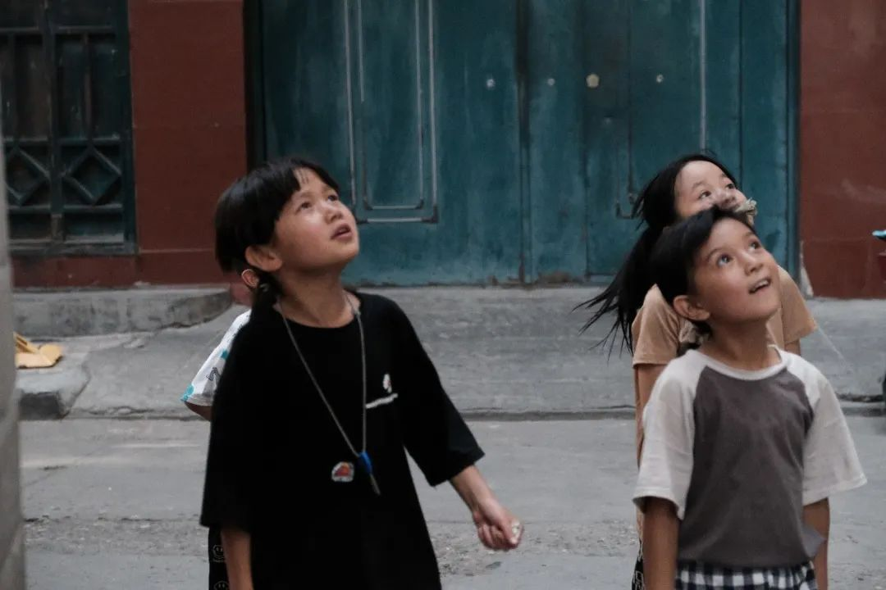

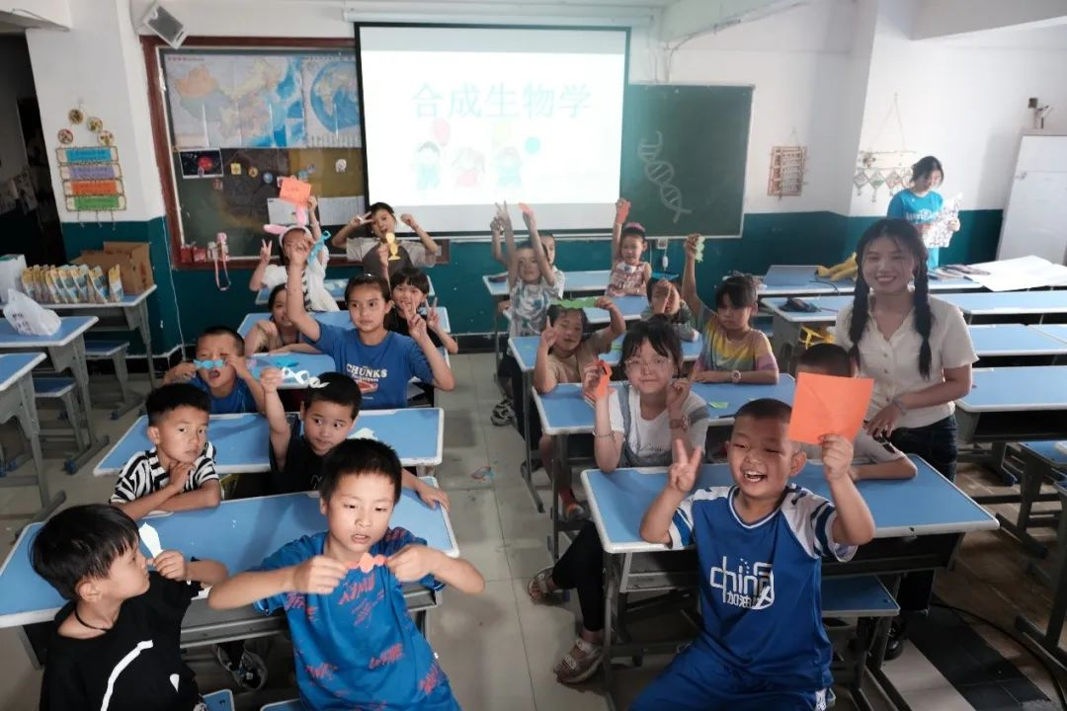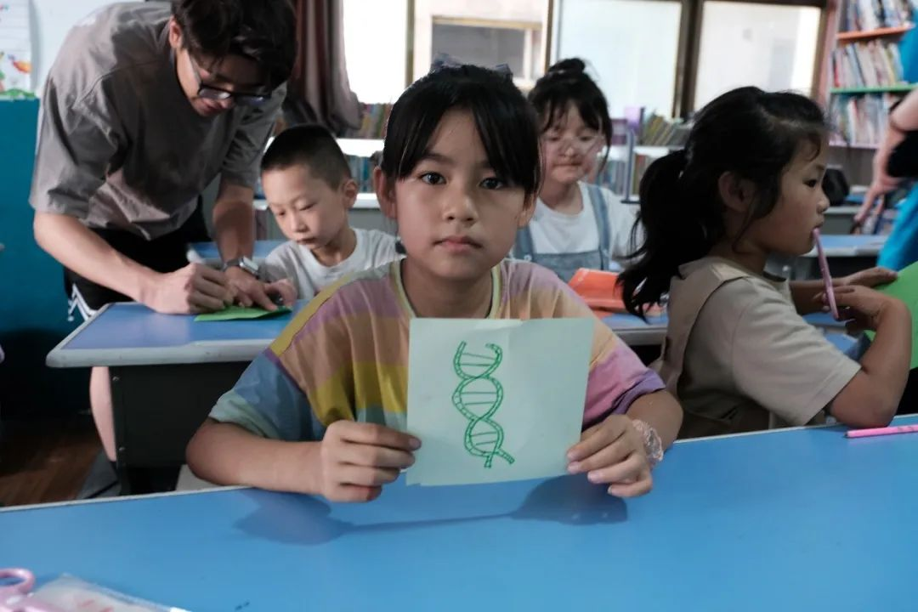

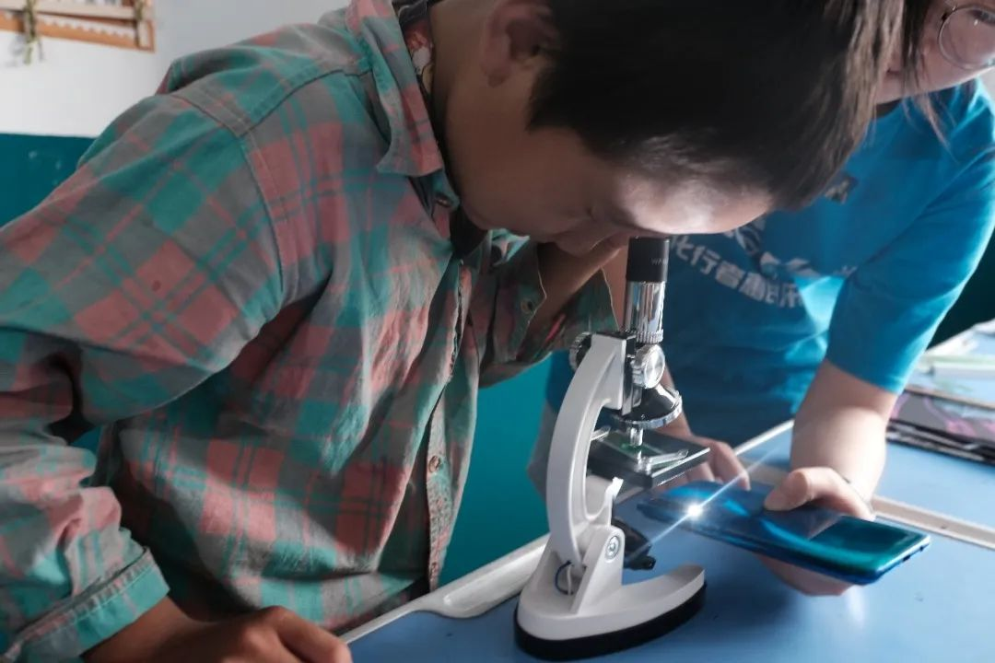

The children in Camel Lane are mainly Hui and Dongxiang, with Islam as their main faith, and most of them are migrant children who follow their parents to move around a lot. We gave them an introduction to synthetic biology, worked with them to design a biological original on paper, and led them to observe onion cells using a microscope. This was the first time they came into contact with a microscope and the world under the microscope's perspective. We had a great time, and by the time we parted, each of us had two lovely children with us. We sincerely hope that our presence will plant a seed of science in their hearts.

In addition, because Mandarin is not so popular in many remote minority areas, we have configured our science videos in Tibetan, so that Tibetan children can also learn through their mother tongue, eliminating the language barrier.

### 2.3 For women's equality in education

According to the results of our survey, 32.22 per cent of female respondents believe that education between them and men is less fair, 11.11 per cent believe it is very unfair and 25.56 per cent say it is fair. As for men, only 11.94 per cent of them think that education between men and women is unfair, 44.78 per cent think that education between men and women is fair and 16.42 per cent think that it is very fair. It can be seen that there is a great difference in the understanding of the right to education between men and women. This is very worthwhile for us to think deeply. Regardless of how we feel about the fairness of education between men and women, the number of women leaders and scientists in China is still far lower than the number of men. There is also a widespread prejudice in China that girls are not suitable for science. And in remote rural areas, there is still a tendency to send boys to school if the family is in financial difficulty. Our team also discussed the issue of equality between men and women in education. There is no doubt that men are in an advantageous position, and under such conditions, people may not realise that they have rights that others do not have, and they may be less vigilant and aware of unfairness. It is hoped that more men will become aware of their inherent advantages and commit themselves to a wider equality between men and women.

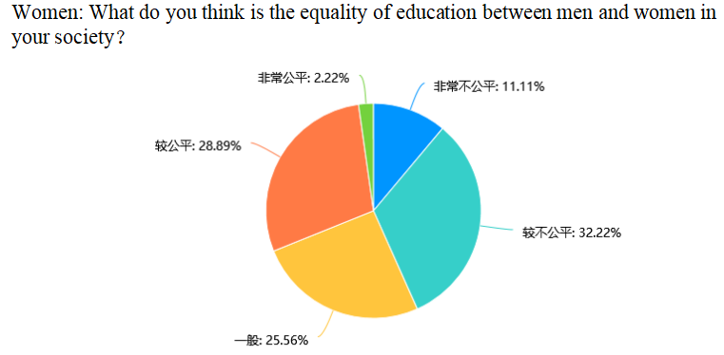

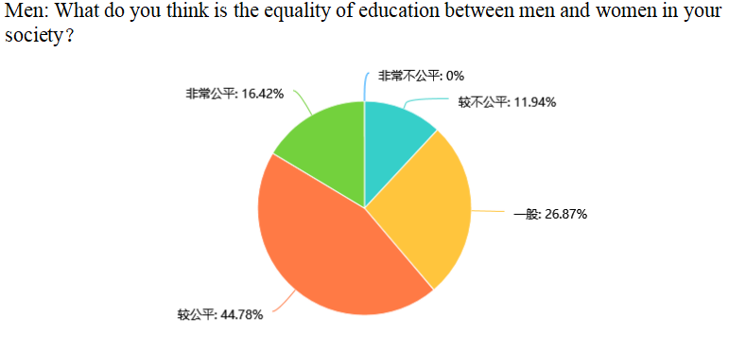

To this end, we targeted fun science activities for female audiences, we conducted health promotion activities for elderly women and made creative handmade soaps with them. We also sent a batch of creative tools designed by our team to the famous Zhang Guimei Girls' High School in China to support women's education.

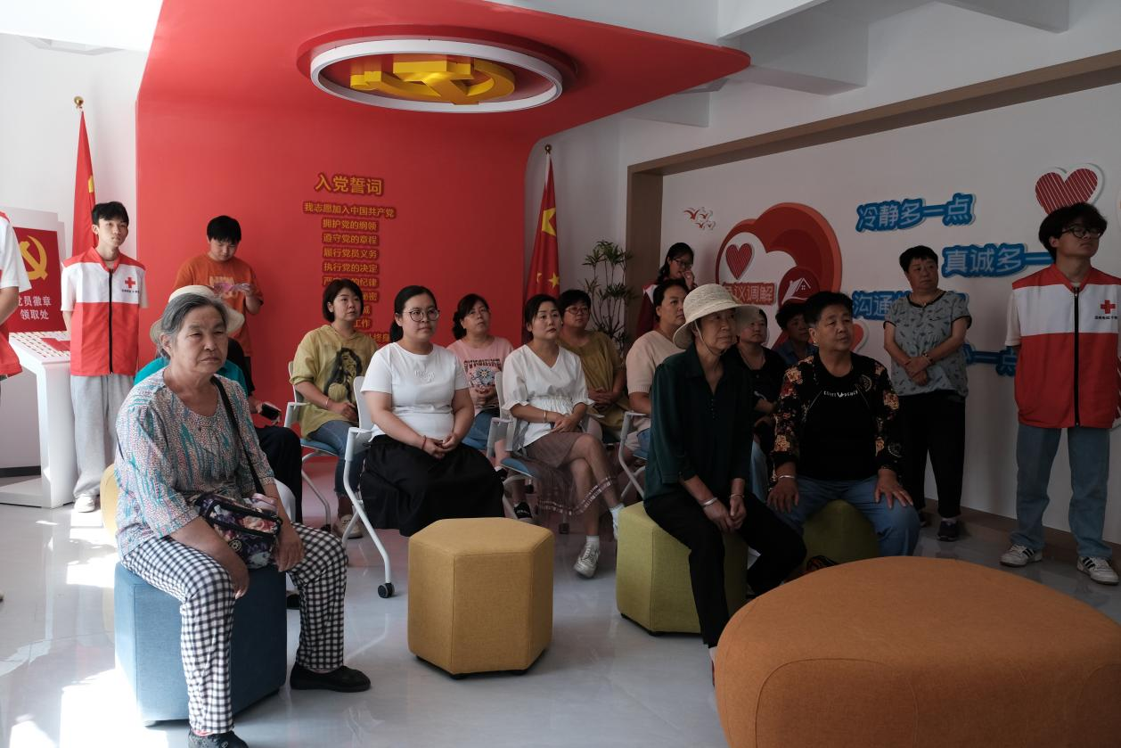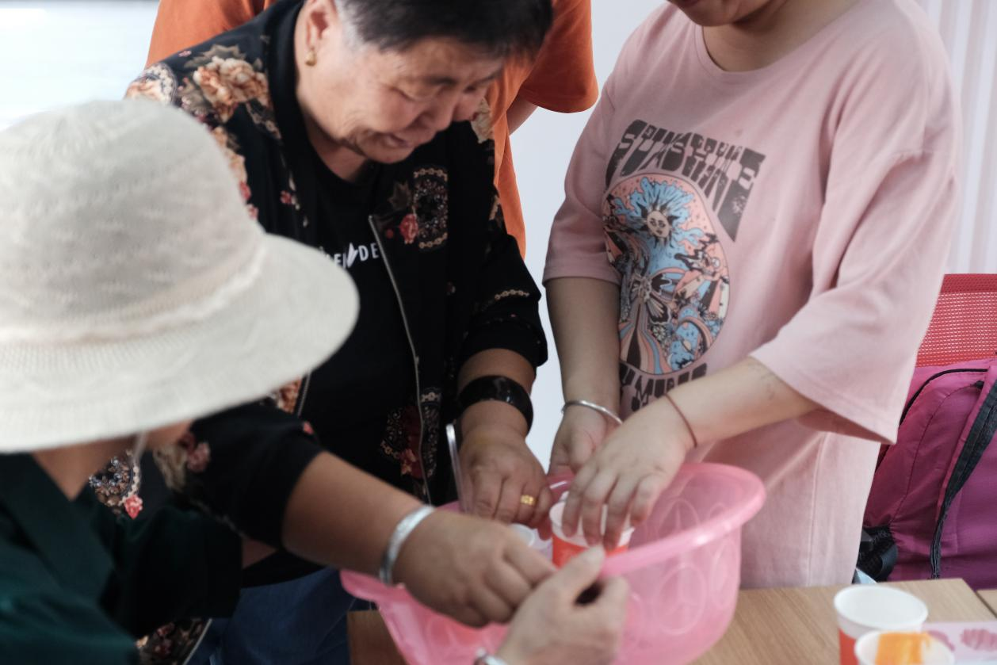

Specifically analyzing the main reasons for the inequity in female education, according to the data in question five of our questionnaire, there are the following: firstly, cultural attitudes and gender bias:

1. In some social and cultural contexts, females are regarded as the main bearers of family roles rather than the pursuers of equal educational opportunities. This may stem from traditional attitudes that lead to restrictions and discrimination against females in education.

2. Secondly, expectations from the family and pressure from society: Expectations and pressures on females from the family and society are also an important factor affecting female education. Family expectations often influence women's choices for their own development, while social pressure may force women to give up the opportunity to pursue higher education in some cases.

3. Then, there is the lack of economic support and resources: economic factors are also an important factor affecting women's education. Some families may not be able to support their daughters' pursuit of higher education due to financial difficulties, which may lead to unequal opportunities for women in education.

4. Policy support: Although the proportion of options is only 16%, it is still very important, and the safeguarded policies can guarantee women's access to education.

As for the other option "Other (please specify)", there is a 3% proportion, which needs to be further analyzed for specific reasons. In general, cultural attitudes, gender bias, family expectations and social pressure are the main factors leading to inequality in female education. In order to address this problem, reforms and efforts are needed at multiple levels, including changing social attitudes, providing economic support and resources, alleviating family and social pressure, and strengthening policy support. We believe that the most important thing in realizing equality between men and women is to change people's mindset. We will further utilize our power to call for equality between men and women and to fight for more educational resources for women.

# LGBTQ

**Our project is related to the prevention of hypercholesteremia,so we tried our best to explore which parts of the project might have overlooked the claims of some groups.**

**After preliminary background research and literature review,we found that in China,the rights issues of the LGBTQ community are neglected by publicity due to relatively conservative policies.LGBTQ community also be called as SGM,so we probably use SGM in the subsequent descriptions.**

## **1.Initial background research**

According to the literature, one group that may be at risk for obesity[1] and disordered eating[2] is sexual and gender minorities (SGM; those who identify as lesbian, gay, and/or transgender or whose sexual orientation and/or gender identity/expression do not conform to societal conventions. bisexual,and/or transgender or whose sexual orientation and/or gender identity/expression do not conform to societal conventions). There is a significant association between a higher prevalence of obesity and the incidence of hyperlipidemia as well as an increased incidence of cardiovascular disease [3].

Policy-wise, LGBT people face health disparities due to stigma, discrimination and violence, according to the Centers for Disease Control and Prevention's Healthy People 2020 study. But researcher Fredriksen Goldsen says those problems spike as lesbian, gay, bisexual and transgender people age. It was a federally funded project that followed 2,450 LGBT adults between the ages of 50 and over 100.

"We found a range of high-risk factors, including a history of victimisation and an inability to access the services they need," University of Washington Healthy Generations Hartford Center of Excellence Professor and Director Fredriksen Goldsen, professor and director of the Healthy Generations Hartford Centre of Excellence at the University of Washington. She said, "Not everyone is in bad health; in fact, most people are in good health." "But we want to understand poor health in this community." About 13 percent of LGBT older adults medically reported being denied or given poor care because of their sexual or gender identity.

* Among transgender participants, that percentage jumps to 40 per cent. Fredrickson-Gordon said, "So many people are not getting medical care or are receiving poor-quality medical care that they are now becoming more hesitant to get medical care." According to the study, older LGBT adults are more likely than heterosexuals to smoke excessively, drink heavily and be depressed. Differences were even found in subgroups of the LGBT community, some of whom had more serious health problems than others: the
* Hispanic and African American older gay men are more likely to report having AIDS than their white peers.
*  Hispanic LGBT adults are more likely to have asthma, diabetes, and visual impairment. African American LGBT older adults are more likely to be obese and have high blood pressure.
*  Compared to whites, Native American LGBT older adults are less likely to have cancer but more likely to have poor physical health, disability, obesity, asthma, and cardiovascular disease.
*  Asian Pacific Islander, LGBT older adults are more likely to have visual impairment, but less likely to be obese or have cancer. Exacerbating the problem is the lack of access to quality health care and geriatric services.

According to a recent survey by the American Association of Retired Persons (AARP), about 48 per cent of residents of large cities and 10 per cent of residents of rural areas and small towns say they have access to LGBT older adult services in their communities.

Based on this data, we also wanted to understand the prevalent perceptions of LGBTQ issues in China. To do this, we distributed questionnaires and collected a total of 162 valid data. When we asked the public about their knowledge of LGBTQ people, more than 92% had some knowledge of the group, of which 14.81% knew a lot about the group, which shows that China is still relatively tolerant of the group, but just a little conservative in its policies.

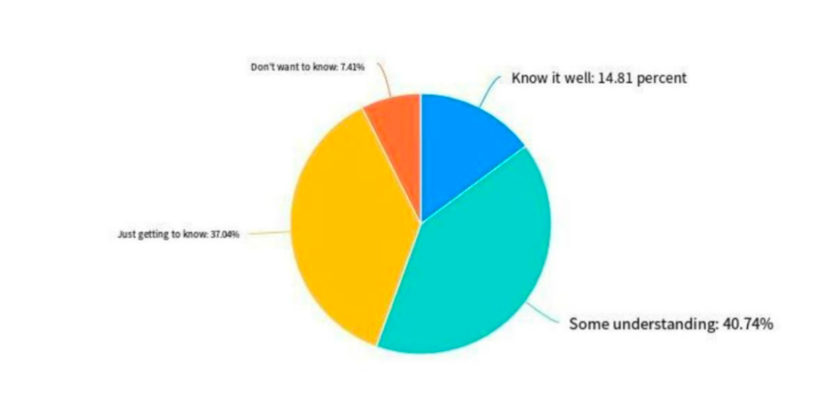

When we asked the public about their attitudes towards the LGBTQ community, we found that only 1.23 per cent were firmly against it, 9.26 per cent were against it but understood their behaviour, but close to 80 per cent were able to understand and respect it, which suggests that Chinese society has become more tolerant of the LGBTQ community, and is only a little bit conservative in terms of its policies.

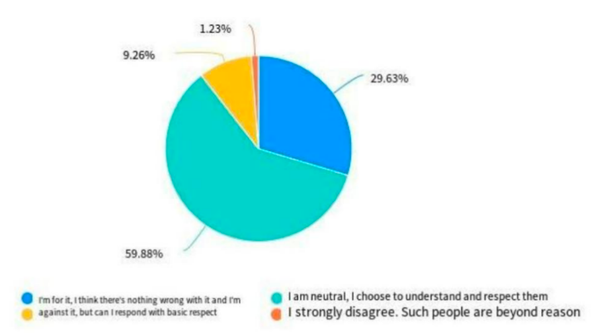

When we asked the public about their knowledge of the LGBTQ community's higher rates of obesity, dyslipidemia, and poorer cardiovascular health, more than 54% said they were completely unaware of the phenomenon, and only 17.9% were aware of it, and even those who were aware of it were basically unaware of the reasons for it, which suggests that it has received little attention in this area in the country, and that this survey is necessary. This indicates that this aspect has received very little attention in the country, and therefore it is necessary to conduct this survey.

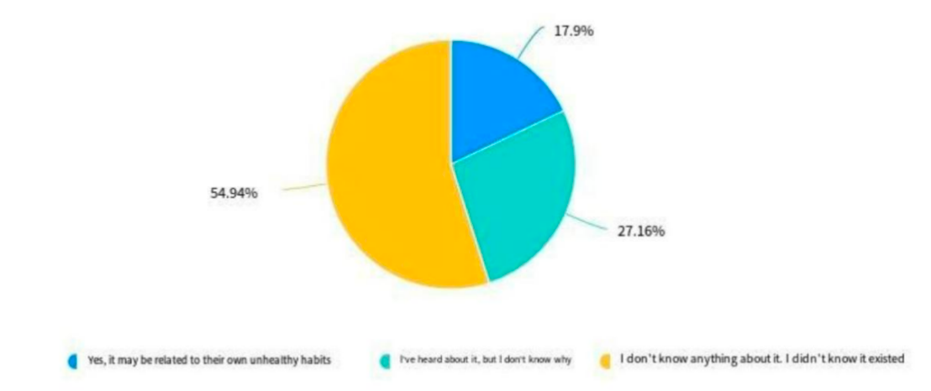

When we asked the public what they thought about the LGBTQ community in terms of the high prevalence of dyslipidaemia and poorer cardiovascular health, more than 71% said they were not sure or even didn't understand it, with the majority believing that the community is also just supposed to be otherwise no different from the norm except for the psychological issues, while at the same time, some (20.99%) said they fully understood and believed that they are physiologically different from heterosexuals and that they need special forms of care and treatment. This also shows that most of the attention to this part of the population is very low, and part of the country is still very tolerant of this group and willing to help and support them.

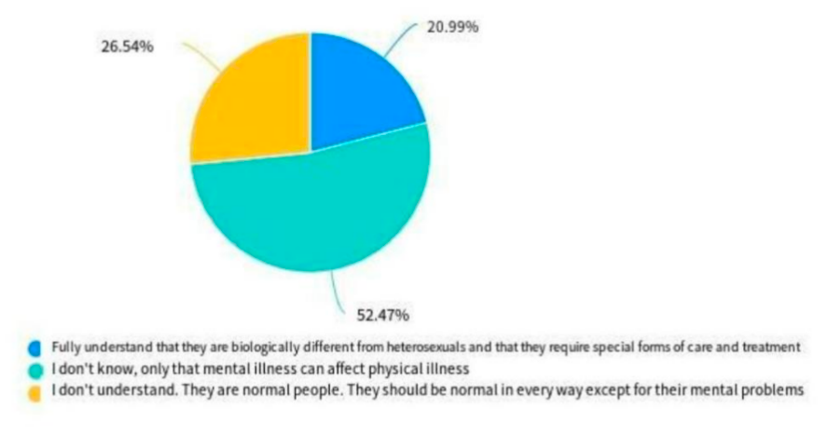

When we asked the public what they thought could be done to promote the right to health and medical care for the LGBTQ community, the most recognised actions were the efforts to realise the needs of the LGBTQ community in the event of illness and the development of appropriate health education for the LGBTQ community.

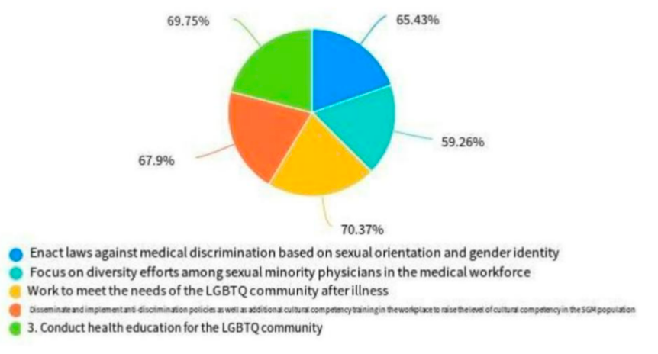

## 2.The Promotion of Brochure and Written Proposal in China

Our school,Lanzhou University,locates in the northwest of China.The economy of the northwest in China is not as developed as that of the southeast coast,and people are not as open-minded.So we decided to promote LGBTQ and cancer issues begin at northwest.

For publicity,we wrote a brochure in understandable language that contains three parts:our background research,initiatives for LGBTQ people to stay healthy and wishes.We printed about 50 copies and put them in the First Hospital of Lanzhou University and Gansu Provincial Hospital,mainly on the tables of the service counter on the first floor(figure 1)and on the shelves for renting power bank(figure 2).

These brochures did attract a certain number of patients who come and go to read them in the hope that they will dispel the prejudice against the LGBTQ community,at the same time make the LGBTQ community more aware of their health issues and timely medical checkups.

传brochure_1。pdf

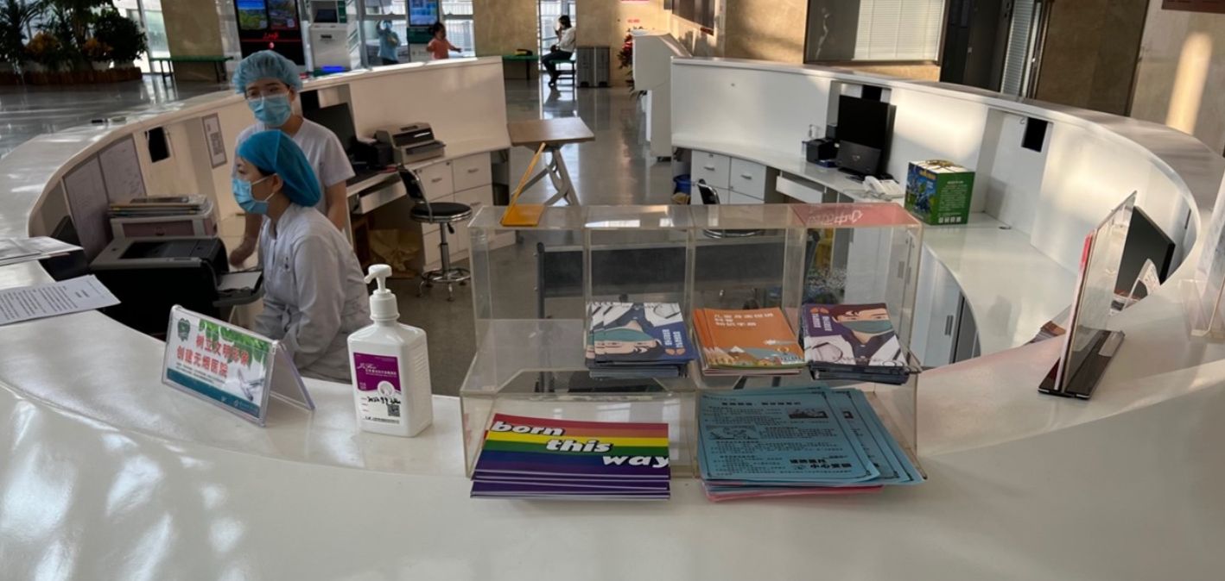

Figure 1.brochures on the service counter

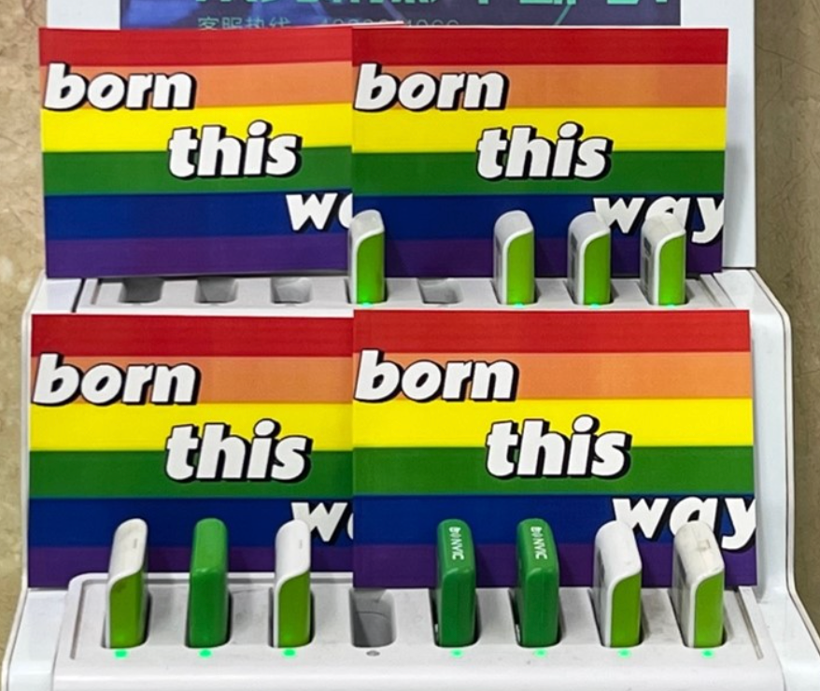

Figure 2.brochures on the shelves for renting power bank

For health care workers,(we chose this group because they have the most contact with LGBTQ cancer patients and are the most influential factor in their health care experience)we drafted a written proposal based on the disregard for LGBTQ patients in the Chinese healthcare system.We want to do what we can to enhance the experience of LGBTQ patients and bring this group to the forefront of health care professionals'attention.

For healthcare professionals(a group we chose because they have the most contact with LGBTQ patients and are the most influential factor in their healthcare experience),we have drafted a written proposal based on the disregard for LGBTQ patients in the Chinese healthcare system.We want to do what we can to enhance the experience of LGBTQ patients and bring this group to the attention of healthcare professionals.

传proposal。pdf

We also took action at the two hospitals mentioned above.We first communicated with some of the nurses about whether they had considered the LGBTQ community in their work,and most of them said that they had not considered these groups.We then distributed our written proposal to them and discussed the future of the LGBTQ community in China.

## 3.Bringing this Issue to the International Stage

The problem of disregard for LGBTQ rights does not only occur in China, we learnt from our Thai professors in the lab that the same problem exists in Thailand.

Tawatchai Sumpradit, Head of the Department of Microbiology and Parasitology, Faculty of Medicine, Naresuan University, Thailand, was the Assistant to the President of Naresuan University for Academic Affairs (2012-2016) and the Assistant to the Dean of the Faculty of Medicine for Business Collaboration (2003-2006).

Therefore, we found that taking action in China alone was not enough, so we contacted the Thai professor. In order to understand the situation and difficulties of LGBTQ in each other's country, we had a meeting about the zoom issue and also discussed how to move forward with the project in Thailand next.

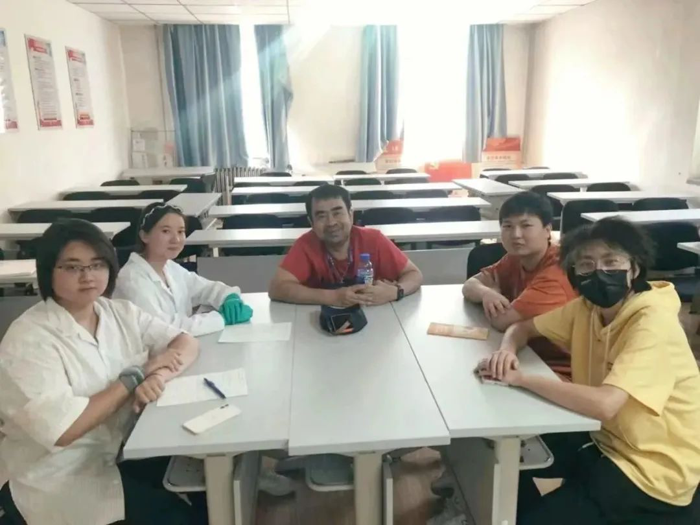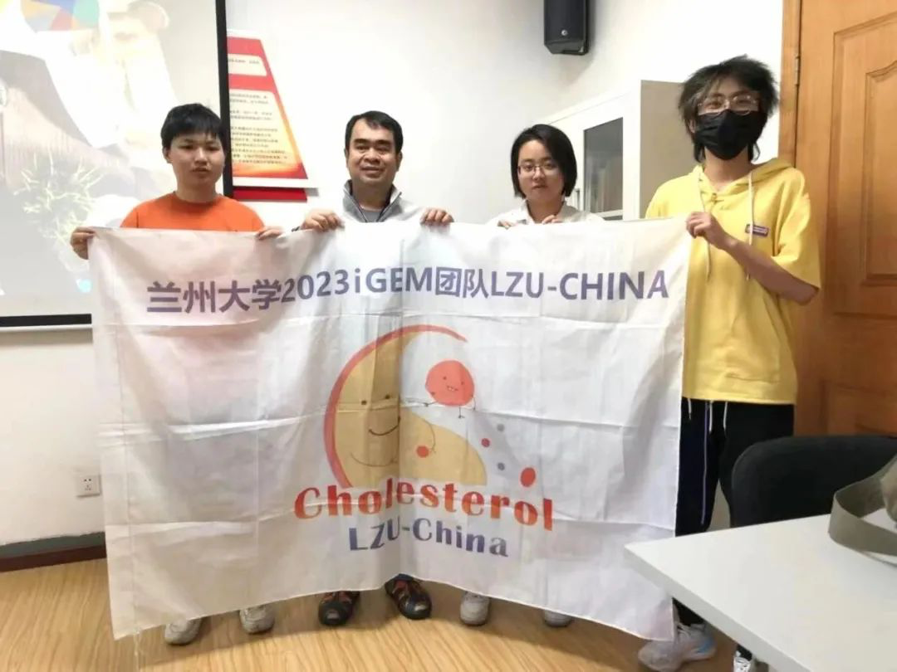

Regarding this population, Prof. Tawatchai had this to say: The LGBTQ community in Thailand is gradually becoming more recognised in society, especially in big cities such as Bangkok, where LGBTQ individuals have more opportunities to show their identity and participate in social activities. However, despite the absence of discriminatory provisions in the law, prejudice and discrimination against LGBTQ people still exist in society, especially in rural areas. In addition, rights and interests with regard to gender identity and sexual orientation still face challenges, such as the legalisation of same-sex marriage, which has not yet been achieved.

As for hypercholesterolaemia, some studies suggest that certain LGBTQ people may be at higher risk. This may be related to psychological stress, social exclusion, poor lifestyles and challenges accessing healthcare. More research is needed to gain a deeper understanding of this phenomenon and to take measures to improve mental health and healthcare access for LGBTQ people in order to reduce the risk of chronic diseases such as hypercholesterolaemia.

Currently, research on hypercholesterolaemia in the LGBTQ population in Thailand is relatively limited and future research directions could include the following:

1. **Epidemiological studies**: to gain further insight into the prevalence and risk factors of hypercholesterolaemia in the LGBTQ community in order to establish more comprehensive epidemiological data.

2. **Social factor analysis**: to study the impact of social and cultural factors on the health status of the LGBTQ community, including factors such as social exclusion, discrimination, family support and identity.

3. **MENTAL HEALTH RESEARCH**: to explore the mental health challenges of LGBTQ individuals and how these challenges are associated with hypercholesterolemia. Understand how factors such as psychological stress, anxiety, and depression influence lifestyle and food choices.

4. **INTERVENTION AND PREVENTION STRATEGIES**: develop and evaluate intervention and prevention strategies for hypercholesterolemia for the LGBTQ community, including outreach, education, health promotion, and healthcare visits.

5. **Social Support and Policy Research**: research on the impact of LGBTQ advocacy and social support policies on their health and lifestyles to ensure that equal rights are enforced.

6. **Lifestyle Interventions**: to explore strategies to mitigate the risk of hypercholesterolemia through lifestyle changes such as improving diet, increasing physical activity, and reducing smoking and alcohol abuse.

These research directions will contribute to a more comprehensive understanding of hypercholesterolemia in the LGBTQ community and provide a strong basis for developing effective prevention and intervention strategies.

# Sign language

In order to ensure that deaf people can watch and gain knowledge from it without any problems, we have worked closely with the Lanzhou University Sign Language Association to provide sign language versions of our science videos. In this way, we aim to provide deaf people with more access to scientific knowledge and help them better integrate into society.

# Wiki Accessibility

Our Wiki pages accessibility production is progressing rapidly.It can meet the needs of different people for different styles,and users can switch the background color of the Wiki page and the background graph by clicking the button.At present,the writing of css and the production of page buttons have been realized,and further rendering and use will be carried out in the future to make our Wikis more readable and convenient.Follows are the screenshots of our menu and the unfinished codes.

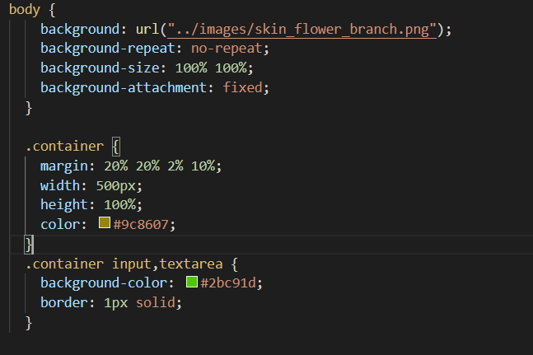

# Colour Blindness

We have provided colour blindness enhancements to our web pages in order to provide an equal access experience for those users who are unfortunate enough to suffer from colour blindness. Through this feature, these users will be able to browse and access the information on the web pages without any barriers, thus enjoying our learning resources to the fullest.

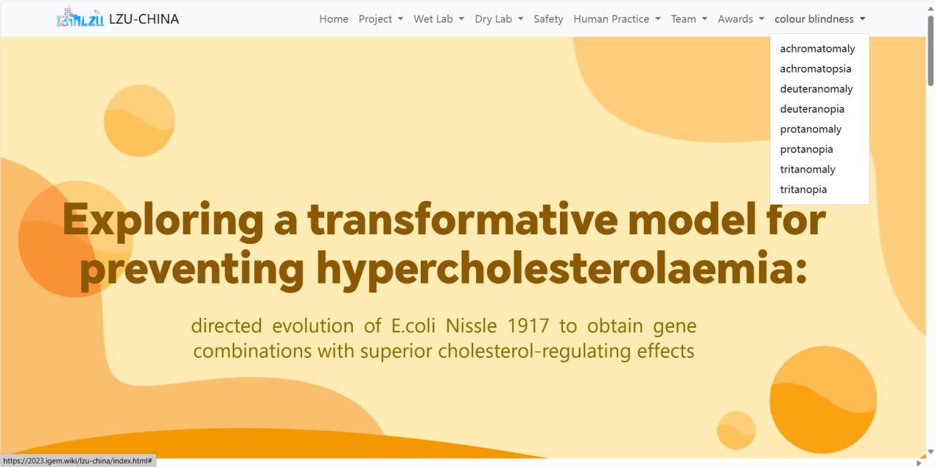

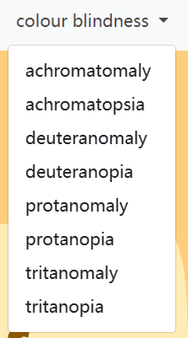

# Autistic children

We have designed a programme of fun science activities for autistic children, hoping to add a point of care for autistic children, through our power to make them feel the warmth of this world a little more (on the programme of activities for autistic children).

# Disabled children

Physical disability does not define life. The progress of the society is to let the disabled people who used to stay at home to get the support and encouragement to challenge the world and be full of courage to meet all the things in the world. Our team made contact with a little girl with cerebral palsy through the Liuzhou Women's Federation and the Disabled Persons' Federation. We visited her family and accompanied her to a Lego class. Children with disabilities may have physical disabilities, but that doesn't mean they have intellectual problems. On the contrary, they may be able to shine in fields such as robotics and programming.

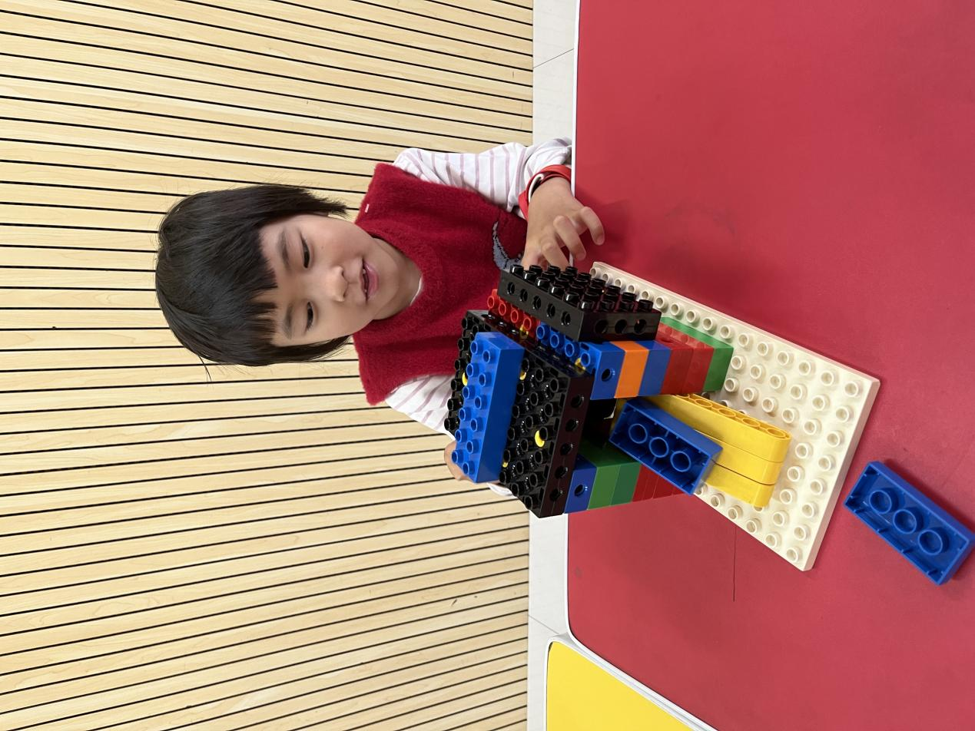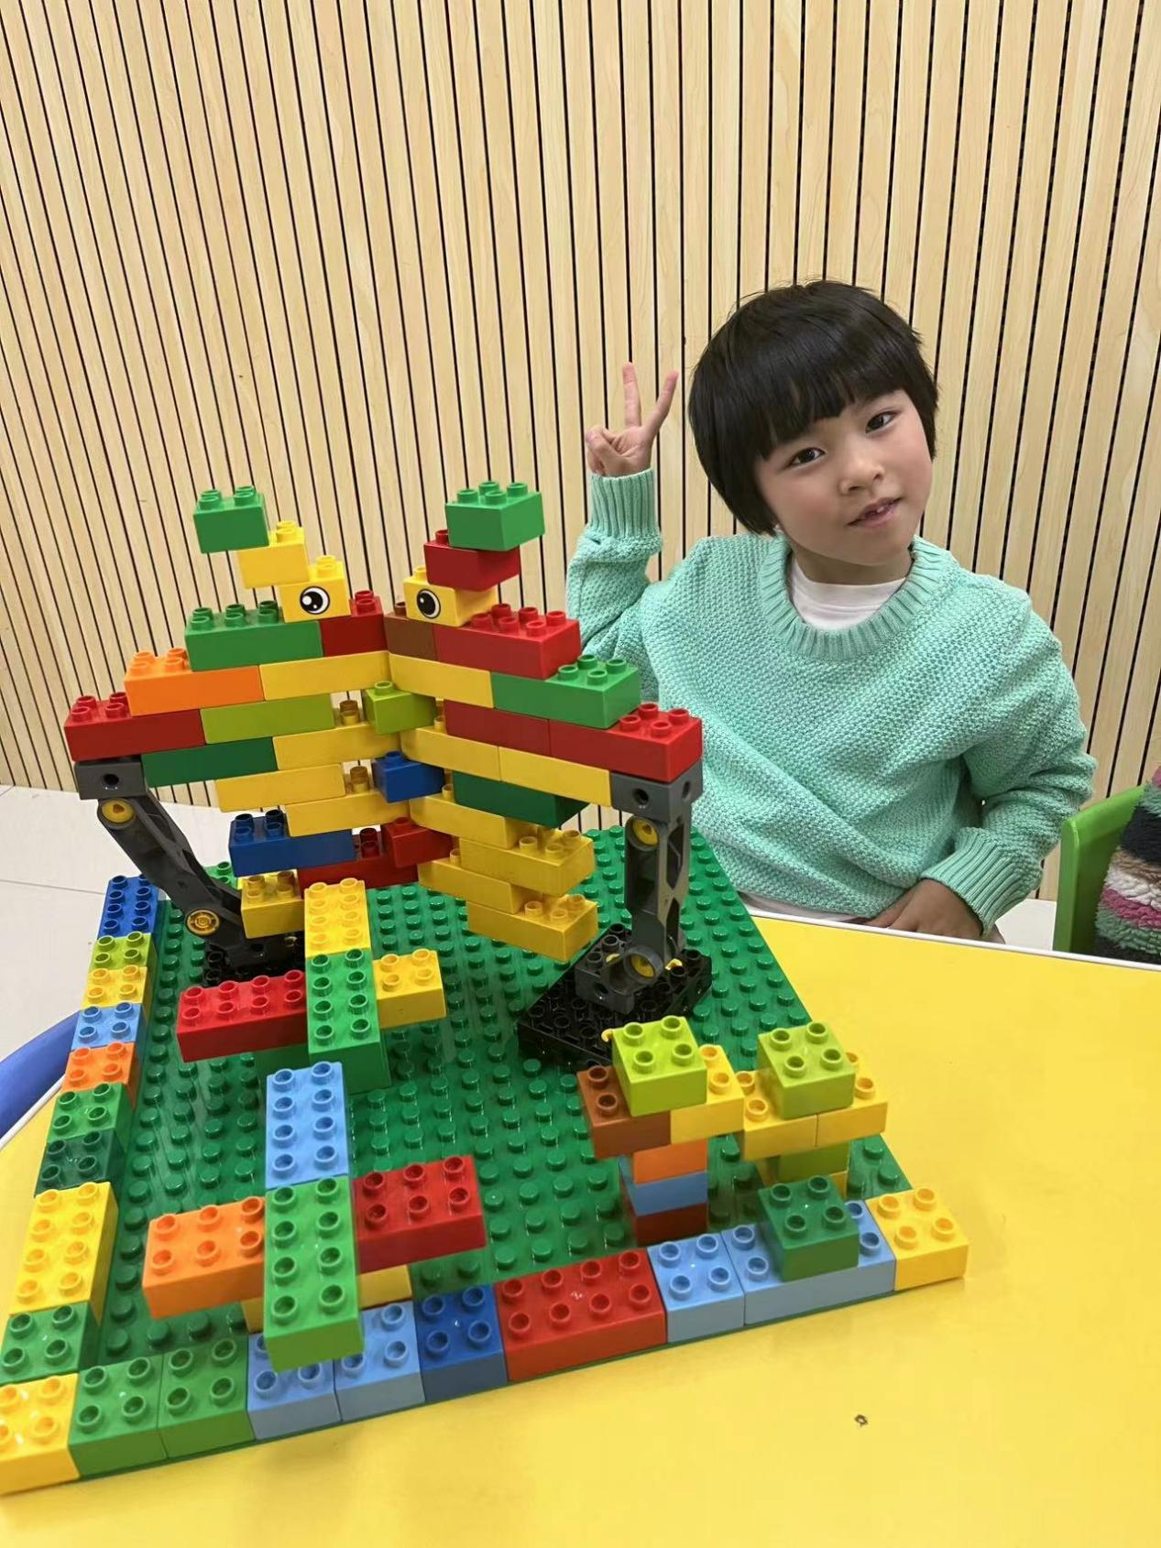

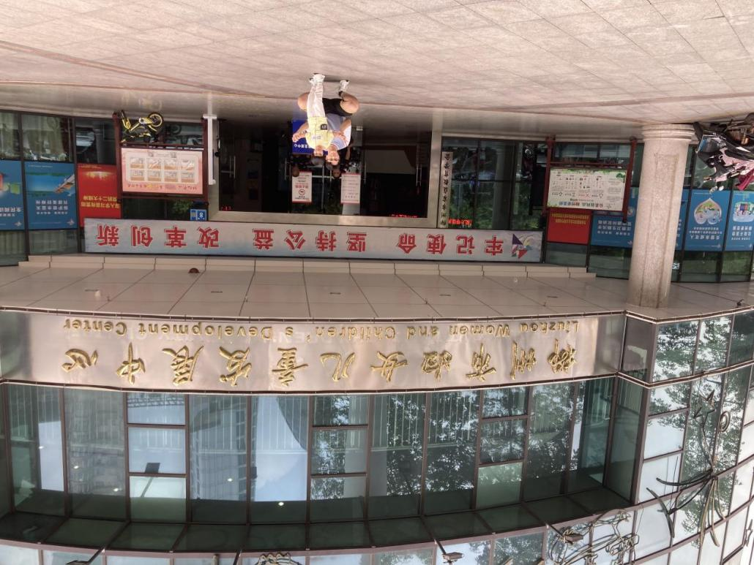

# Elderly groups

After an introduction, we visited the Baiyun Care Home in Liuzhou City. There, we presented gifts to the elderly and carried out science popularisation activities. Everyone has parents, and the health of parents is the best gift to children in the struggle. A happy environment can maximise social progress. In addition, we have conducted several health education activities for the elderly to raise their health awareness.

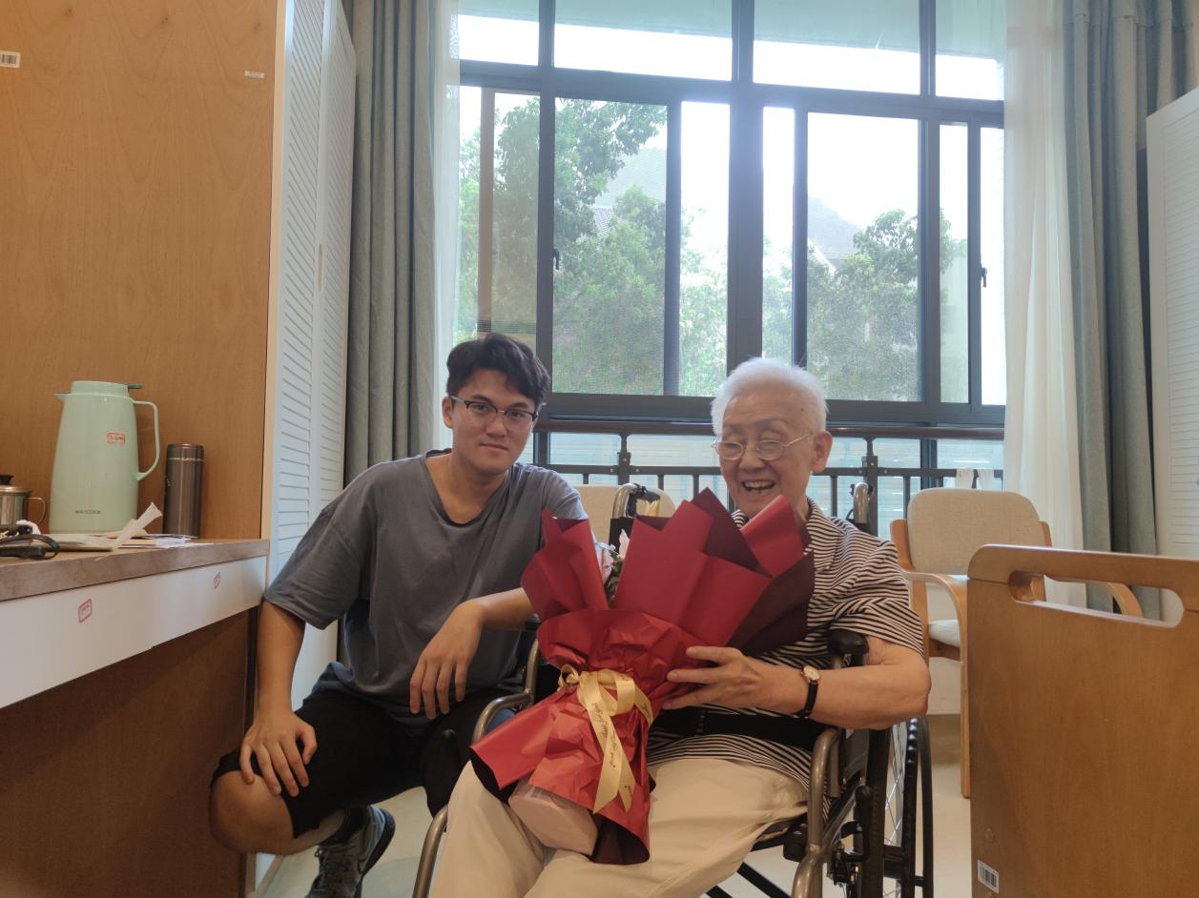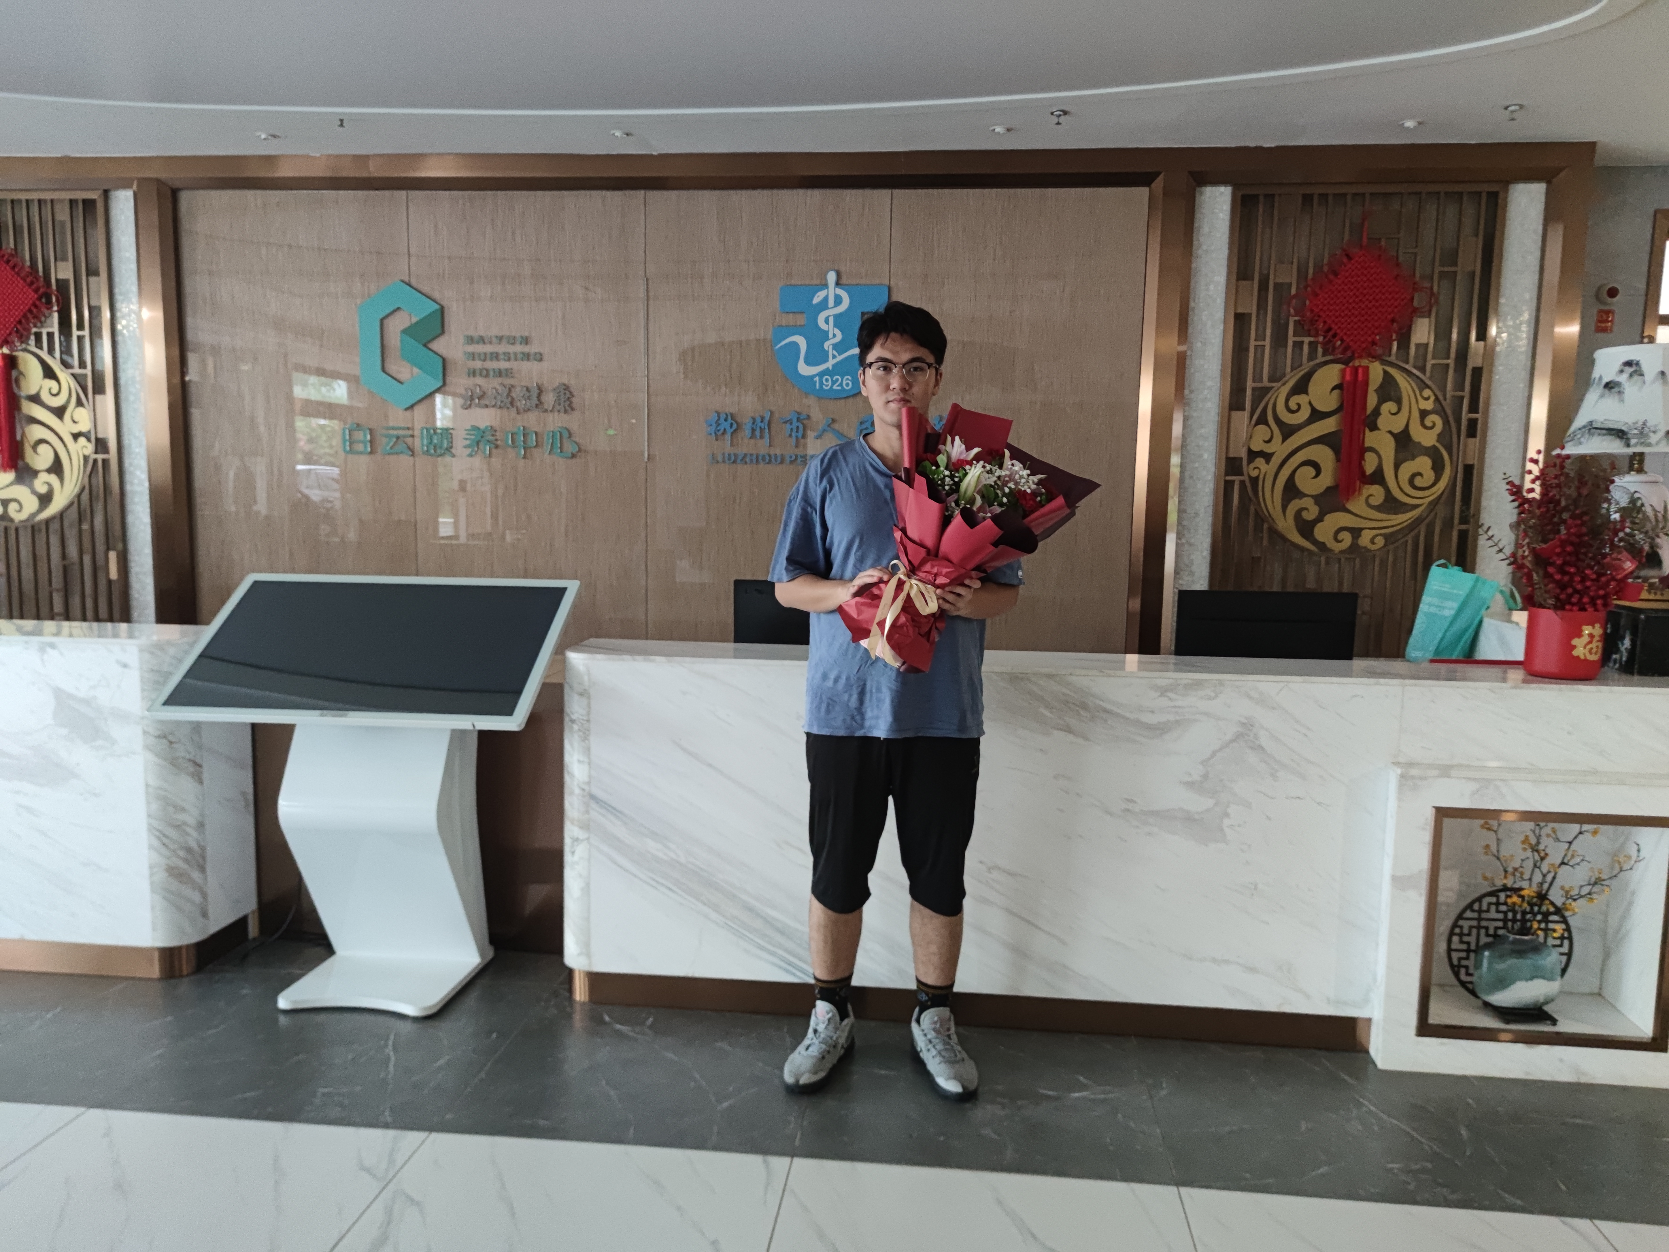



# Differences in the eating habits of people in different regions

Northwest China has a large number of ethnic minorities, and different ethnic groups have different customs and even religious beliefs. We note that most of the current hypercholesterolaemia recipes are for Han Chinese, who make up more than 90% of the total population. However, there are also a considerable number of Hui, Dongxiang, and other people who believe in Islam, as well as Tibetans, living in the Northwest, especially in Lanzhou and Linxia. For this reason, we have joined forces with the Department of Nutrition of the First Hospital of Lanzhou University to launch a cookbook that can cover the local Hui, Dongxiang and other ethnic groups who believe in Islam. We propose our solution to the problem of different rates of dyslipidaemia brought about by differences in dietary habits among different ethnic groups. **（挂食谱与饮食指导的word）**

In the process of exploring how to improve the inclusiveness of the project and the world, we have developed our curriculum vitae and our knowledge. We have also learnt how to communicate with different age groups, different ethnic groups and how to promote science. If you have any suggestions, please don't hesitate to contact us so that we can learn and achieve more, we really want to include you and include all.